“And the peace of God, which surpasses all comprehension, will guard your hearts and your minds in Christ Jesus.” -- Philippians 4:7
- Please show all your work! No partial credit will be given for incorrect answers with no work shown. Please draw a box around your final answer.
- Calculators are permitted, but no notes, text, laptops, PDAs, or electronic dictionaries.
- Cell phones should be muted and left in your pocket or bag.
Total marks: 70

- 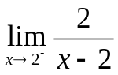 [2]
-∞
- 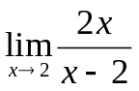 [2]
Does not exist
- 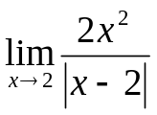 [2]
+∞
- 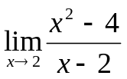 [2]
4
- 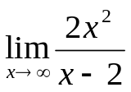 [2]
+∞
- 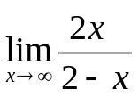 [2]
-2
- 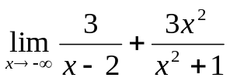 [2]
3
- Let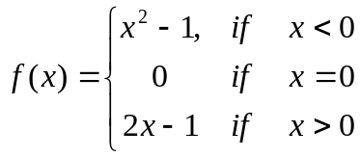.
  - 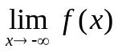 [2]
+∞
  - 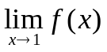 [2]
1
  - 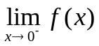 [2]
-1
  - Is f(x) continuous at x=0? [2]
No
- Solve: x³ – 10x² – 24x < 0 [3]
(-∞, -2) and (0, 12)
or: x < -2 and 0 < x < 12
- Solve: 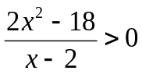 [3]
(-3, 2) and (3, ∞)
or: -3 < x < 2 and x > 3
- Solve: 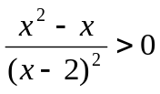 [3]
(-∞, 0) and (1, ∞)
or: x < 0 and x > 1
- Solve: (x+5)(x+1)x(x-3)² < 0 [3]
(-∞, -5) and (-1, 0)
or: x < -5 and 0 < x < -1
- Find (simplify): 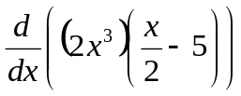 [3]
6x²(x/2 – 5) + x³
= 4x³ – 30x²
- Find (simplify): 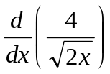 [3]
-(√2)x^{-3/2}
- Find (simplify): 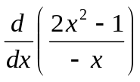 [3]
-2 – x⁻²
- Find (simplify): 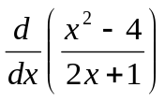 [3]
( (2x)(2x+1) – 2(x²-4) ) / (2x+1)²
= ( 2x² + 2x + 8 ) / (2x+1)²
- Let 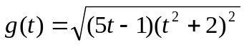.
Find 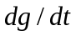 (no need to simplify). [4]
(1/2) * ((5t-1)(t²+2)²)^{-1/2} *
( 5(t²+2)² + 2(5t-1)(t²+2)(2t) )

- Find the equation of the line tangent to the curve 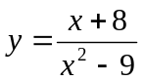 at the point (2, -2). [4]
dy/dx = ( (x²-9) – 2x(x+8) ) / (x²-9)²
= ( -x² – 16x – 9 ) / ( x² – 9 )²
@x=2: dy/dx = -9/5
@(x,y)=(2,-2): y = -(9/5)x + 8/5
- The position in metres of a particle in a certain changing magnetic field is 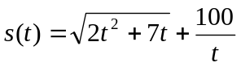, where t is time in seconds. What is the velocity (rate of change) of the particle at t=7 seconds? (Calculator approximation okay.) [4]
-0.59744 m/s
- The demand curve for a certain product is modeled as: 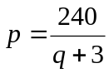, where p is price in dollars and q is thousands of units demanded.
  - What is p(0)? Interpret this in the context of customer demand. [3]
p(0) = $80: at this price nobody will buy the product
  - What happens as 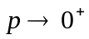? Interpret this in the context of customer demand. [3]
q goes to infinity: infinite demand for a free product
  - How many units are demanded when the price is $24? [1]
7 thousand
  - Write an expression for revenue as a function of quantity demanded. [2]
r = pq = 240q / (q+3)
  - Say the current demand is for 9 thousand units. What is the rate of change of the revenue with respect to quantity demanded? [4]
dr/dq = 720/(q+3)²
@q=9: dr/dq = 5
($ per thousand units)
  - If there are m employees, they can produce 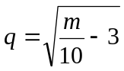 (thousand) units per day. How many employees are needed to meet the demand of 9 thousand units? [3]
840
  - Calculate the marginal-revenue product at the current demand of 9 thousand units. Give an exact answer. ? [4]
dq/dm = (1/20) (m/10 – 3)^{-1/2}
@m=840: dq/dm = 1/180
dr/dm = (dr/dq)(dq/dm) = (5)(1/180) = 1/36
- Find the marginal-cost function if the average cost per unit is 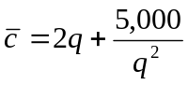. [3]
c = 2q² + 5000/q
dc/dq = 4q – 5000/q²
- If 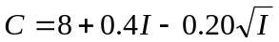 is a consumption function, find the marginal propensity to save when I=4. [4]
dC/dI = 0.4 – 0.1/√I = 0.65

